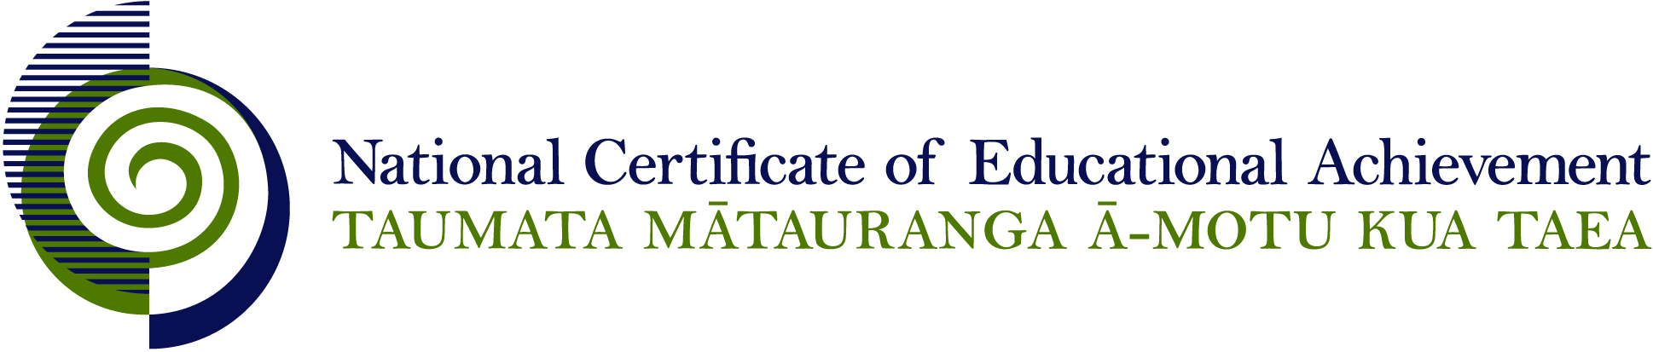

NCEA Level 2 Music

Conditions of Assessment

General Information

Subject Reference | Music
Domains | Making Music and Music Studies
Level | 2

Conditions of Assessment

These Conditions provide guidelines for assessment against internally assessed Achievement Standards. Guidance is provided on:
- specific requirements for all assessments against this Standard
- appropriate ways of, and conditions for, gathering evidence
- ensuring that evidence is authentic.

Assessors must be familiar with guidance on assessment practice in learning centres, including enforcing timeframes and deadlines. The NZQA website offers resources that would be useful to read in conjunction with these Conditions of Assessment.

The learning centre’s Assessment Policy and Conditions of Assessment must be consistent with NZQA’s Assessment Rules for Schools with Consent to Assess. This link includes guidance for managing internal moderation and the collection of evidence.

Gathering Evidence

Internal assessment provides considerable flexibility in the collection of evidence. Evidence can be collected in different ways to suit a range of teaching and learning styles, and a range of contexts of teaching and learning. Care needs to be taken to allow students opportunities to present their best evidence against the Standard(s) that are free from unnecessary constraints.

It is recommended that the design of assessment reflects and reinforces the ways students have been learning. Collection of evidence for the internally assessed Standards could include, but is not restricted to, an extended task, an investigation, digital evidence (such as recorded interviews, blogs, photographs, or film), or a portfolio of evidence.

Effective assessment should suit the nature of the learning being assessed, provide opportunities to meet the diverse needs of all students, and be valid and fair.

Ensuring Authenticity of Evidence

Authenticity of student evidence needs to be assured regardless of the method of collecting evidence. This must be in line with the learning centre’s policy and NZQA’s Assessment Rules for Schools with Consent to Assess.

Ensure that the student’s evidence is individually identifiable and represents the student’s own work. The evidence must be an accurate reflection of what the student independently knows and can do, according to the Standard being assessed. This includes evidence submitted as part of a group assessment, evidence produced outside of class time or without assessor supervision, and evidence produced with any use of generative artificial intelligence tools (GenAI). GenAI use should be carefully considered in the context of the Standard being assessed and its Conditions of Assessment, discussed with students before the assessment, and its use must be acknowledged. For example, an investigation carried out over several sessions could include:
- teacher guidance on the nature and extent of acceptable GenAI use, if any
- assessor observations and conversations
- meeting with the student at set milestones or checkpoints
- the student’s record of progress, such as photographic entries or any GenAI prompts used.

Specific Information for Individual Internal Achievement Standards

Achievement Standard Number | 91270 Making Music 2.1
Title | Perform two substantial pieces of music as a featured soloist
Number of Credits | 6
Version | 2

Ideally the audience should include the assessor. The audience may comprise class members, other school students, or members of the community.

Recording must be of sufficient quality to enable viewers/listeners to identify individual performers and musical parts.

Achievement Standard Number | 91274 Making Music 2.2
Title | Perform a substantial piece of music as a featured soloist on a second instrument
Number of Credits | 3
Version | 2

Ideally the audience should include the assessor. The audience may comprise class members, other school students, or members of the community.

The featured soloist must demonstrate substantially different playing techniques and skills on different instrument(s) from those presented for assessment in AS 2.1.

Recording must be of sufficient quality to enable viewers/listeners to identify individual performers and musical parts.

Achievement Standard Number | 91272 Making Music 2.3
Title | Demonstrate ensemble skills by performing a substantial piece of music as a member of a group
Number of Credits | 4
Version | 2

Ideally the audience should include the assessor. The audience may comprise class members, other school students, or members of the community.

Recording must be of sufficient quality to enable viewers/listeners to identify individual performers and musical parts.

Achievement Standard Number | 91271 Making Music 2.4
Title | Compose two substantial pieces of music
Number of Credits | 6
Version | 2

Each completed composition must be accompanied by a statement of authenticity testifying that the composition is the student’s own work. The teacher must authenticate work in progress as the student develops musical ideas.

The student’s individual creative contribution to collaborative composition must be assessed by teacher observation of both the composition process and performance. Teacher/student conferencing, student annotations and diaries, and/or snapshot videos of collaborative processes are all ways of verifying student contribution. Video/audio/written/digital evidence can all be used to identify and verify the individual student’s creative contribution to the collaborative process.

Recording of compositions undertaken by an individual must be of sufficient quality to enable listeners to identify individual musical parts.

Recordings of collaborative compositions must be of sufficient quality to enable viewers/listeners to visually and aurally identify individual performers/musical parts.

Achievement Standard Number | 91273 Music Studies 2.8
Title | Devise an instrumentation for an ensemble
Number of Credits | 4
Version | 2

The instrumentation must be accompanied by a statement of authenticity testifying that it is the student’s own work. The teacher must authenticate work in progress.

Recording must be of sufficient quality to enable listeners to identify individual musical parts.

Achievement Standard Number | 91278 Music Studies 2.9
Title | Investigate an aspect of New Zealand music
Number of Credits | 4
Version | 2

The investigation must be accompanied by a statement of authenticity testifying that it is the student’s own work. The teacher must authenticate work in progress.

